input.doc Name_____________________________

1) Find the limits (if they exist) for the graph of f(x) below.

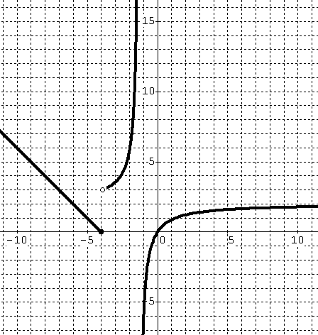
$\vec{{\text{lim}}_{−4^{−} }}f(x)=$__________

$\vec{{\text{lim}}_{−4^{+} }}f(x)=$__________

$\vec{{\text{lim}}_{−4 }}f(x)=$__________

$\vec{{\text{lim}}_{−∞ }}f(x)=$__________

$\vec{{\text{lim}}_{∞}}f(x)=$__________

$\vec{{\text{lim}}_{0}}f(x)=$__________

$\vec{{\text{lim}}_{−1^{−}}}f(x)=$__________

$\vec{{\text{lim}}_{−1^{+}}}f(x)=$__________

2) Find the following limits algebraically.

a) $\vec{{\text{lim}}_{−∞ }}\frac{x^{2}+x}{x^{3}+2x^{2}}$ b) $\vec{{\text{lim}}_{∞ }}\frac{x^{2}+3}{2x^{2}−2}$

c) $\vec{{\text{lim}}_{∞ }}\frac{x^{3}−x^{2}−2}{−2x^{2}}$ d) $\vec{{\text{lim}}_{−∞ }}\frac{x^{3}−x^{2}−2}{−2x^{2}}$

3) Find the following limits algebraically.

a) $\vec{{\text{lim}}_{4^{−} }}\frac{x^{2}+8x+\text{16}}{x+4}$

(a) 0 (b) 8 (c) 16 (d) -∞ (DNE) (e) ∞ (DNE)

b) $\vec{{\text{lim}}_{−4^{−} }}\frac{x^{2}+8x+\text{16}}{x+4}$

(a) 0 (b) 8 (c) 16 (d) -∞ (DNE) (e) ∞ (DNE)

c) $\vec{{\text{lim}}_{5^{+} }}\frac{−x}{x−5}$

(a) 0 (b) 5 (c) $\frac{−1}{5}$ (d) -∞ (DNE) (e) ∞ (DNE)

d) $\vec{{\text{lim}}_{1^{−} }}\frac{−x}{x−5}$

(a) $\frac{−1}{6}$ (b) $\frac{1}{4}$ (c) $\frac{1}{5}$ (d) -∞ (DNE) (e) ∞ (DNE)

e) $\vec{{\text{lim}}_{0^{−} }}\frac{x^{2}−x−\text{12}}{x^{2}−4x}$

(a) -12 (b) 0 (c) 3 (d) -∞ (DNE) (e) ∞ (DNE)

f) $\vec{{\text{lim}}_{3 }}\frac{x^{2}−x−\text{12}}{x^{2}−4x}$

(a) -3 (b) -2 (c) 2 (d) -∞ (DNE) (e) ∞ (DNE)

